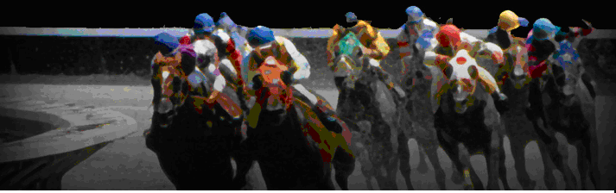
Nite At The Races 2020
A Nite At The Races is the signature event of Meals on Wheels of Chemung County. On Saturday March 21, 2020 more than 300 corporate and community leaders, volunteers and staff will come together at the Holiday Inn Riverview in Elmira for a fun filled evening of horse racing, silent auction, raffles, etc. Nite At The Races’ sponsors will receive the following benefits, based on their investment.

SPONSORSHIP OPPORTUNITIES
Triple Crowne ($2,500) 1 Available
- Full back page or 1st page ad
- Logo on 500 event tickets, (must have logo before January 15, 2020 to be placed on tickets)
SOLD
- Logo featured on all print, TV, social media
- Sponsorship of 1 race
- Announcement of sponsor name during evening and at sponsored race
- 8 tickets to the event and a reserved table

Winner’s Circle ($1,000) 7 Available
- Full page ad in event program
- Sponsorship of 1 race
- Announcement of sponsor name during evening and at sponsored race
- 8 tickets to the event and a reserved table

Owner’s Club ($750) Jockey’s Union ($500)
- 1/4 page ad in the event program
- Name announcement during the evening
- 4 tickets to the event and a reserved table
- 3/4 page ad in the event program
- Name announcement during evening
- 4 tickets to the event and a reserved table

Paddock Seating ($375) 1 Door Prize Sponsor ($500)
- 6 tickets to event and a reserved table
- Provides for a purchase of a major door prize.
- Company featured as door prize sponsor with logo on website and in program.
- Name Listed in event program
Trainer’s Guild ($100)
- 1/8 page ad in event program

$25 Horse Owner: you name the horse and the jockey. Your horse will be announced at the beginning of the race: owner name, horse name and jockey. Please fill out attached form.

Please fill out attached form and send back BY MONDAY MARCH 1, 2020

SPONSORSHIPS MUST MEET DEADLINES TO BE INCLUDED IN PROGRAMS AND SIGNAGE
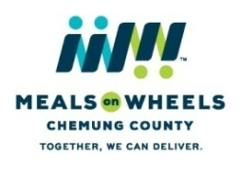

409 William Street, Elmira, NY 14901
607-734-9535
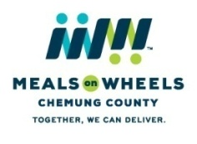
Nite At The Races 2020 – Sponsorship Form
409 William Street, Elmira, NY 14901
607-734-9535

CONTACT INFORMATION (PLEASE PRINT)
Name of Sponsor/Company_________________________________________________________________
Contact_________________________________________________________________________________
Marketing Contact________________________________________________________________________
Address_________________________________________________________________________________
City______________________________________State___________________Zipcode_________________
Phone Number____________________________________________________________________________
Email___________________________________________________________________________________

I WOULD LIKE TO BE A NITE AT THE RACES 2020 SPONSOR: ADS and LOGOS must be received by 2/20/2020
** Triple Crowne Ad and logo must be received by January 15, 2020

_____Triple Crowne Sponsor** ($2,500) _____Winner’s Circle Sponsors ($1,000)
_____Owner’s club Sponsors ($750) _____Jockey’s Union Sponsors ($500)
_____Door Prize Sponsor (only 1) ($500) _____Paddock Seating Sponsors ($375)
_____Trainer’s Guild Sponsors ($100)
_____I/WE DO NOT NEED THE TICKETS _____Please send tickets to the above address

HORSE OWNER: Please fill out and send back by February 28, 2020 in order to be included in the event program. There are 8 races with 10 horses in each race. You may own as many as you wish. Just fill our extra forms for the horse name and jockey. Thank you!

1st Horse Name_____________________________ Jockey Name____________________________ $25
2nd Horse Name____________________________ Jockey Name____________________________ $50
3rd Horse Name_____________________________Jockey Name____________________________ $75
4th Horse Name_____________________________Jockey Name____________________________ $100

____Sorry, I cannot attend but would like to support Meals on Wheels. Enclosed is a donation for $_______
____I would like to donate an item for the silent auction/raffle. ______I can drop it off or:
Please contact Darlene Ike at (607) 734-9535 to arrange for pick up.

Please make checks payable to:
Meals on Wheels of Chemung County

Total amount paid $___________
Credit Cards accepted (circle): Mastercard Visa Amex Discover
Card #:_______________________________________________Security Code:_________________________
Expiration Date:______________________
Name as it appears on the card:________________________________________________________________
Address Associated with card:_________________________________________________________________
City_________________________________State___________________________Zipcode________________
Signature:_______________________________________________Phone #____________________________
Email address for receipt (please print)__________________________________________________________

