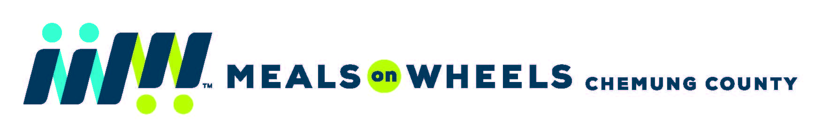
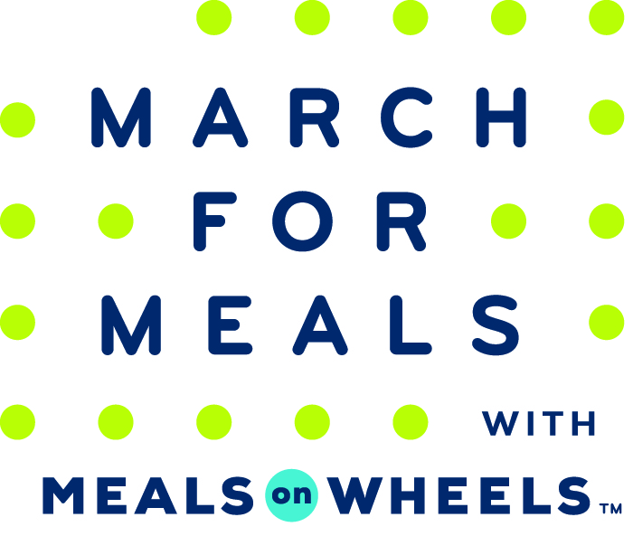

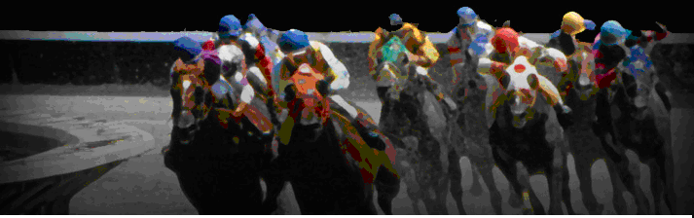

Nite At The Races

Auction Item Donation Form

Please Print Donor/company name EXACTLY as you would like it to appear

Name/Company Name (if from a company)

Address_________________________________________________________________________________

City______________________________________State___________________Zip_____________________

Contact_____________________________________________Title_________________________________

Phone #____________________________Fax:__________________________________________________

Email:___________________________________________________________________________________

Value of Donation:_________________________________________________________________________

Description of donated item and/or gift certificate*________________________________________________

Pick up required ( ) Please reply by February 28, 2018

* Please make gift certificates valid for 1 year

Return to: Meals on Wheels of Chemung County

409 William Street

Elmira, NY 14901

c/o Darlene Ike

If you require further information and/or clarification with regard to this important request, please contact Darlene Ike at 607-734-9535 or at info@mealsonwheelschemung.org or fax this form to 607-734-5267

All items donated may be tax deductible at their present fair market value.

IRS code places the responsibility for estimating the value upon the donor.

